Are you looking for a nice and unique present? Visit us now at Santa Rosaweg # 8
next to Restaurant Number TEN or order your presents online.
Looking for more ambience for the evenings? Thorns The Light Within
lamps will be available in November 2020.
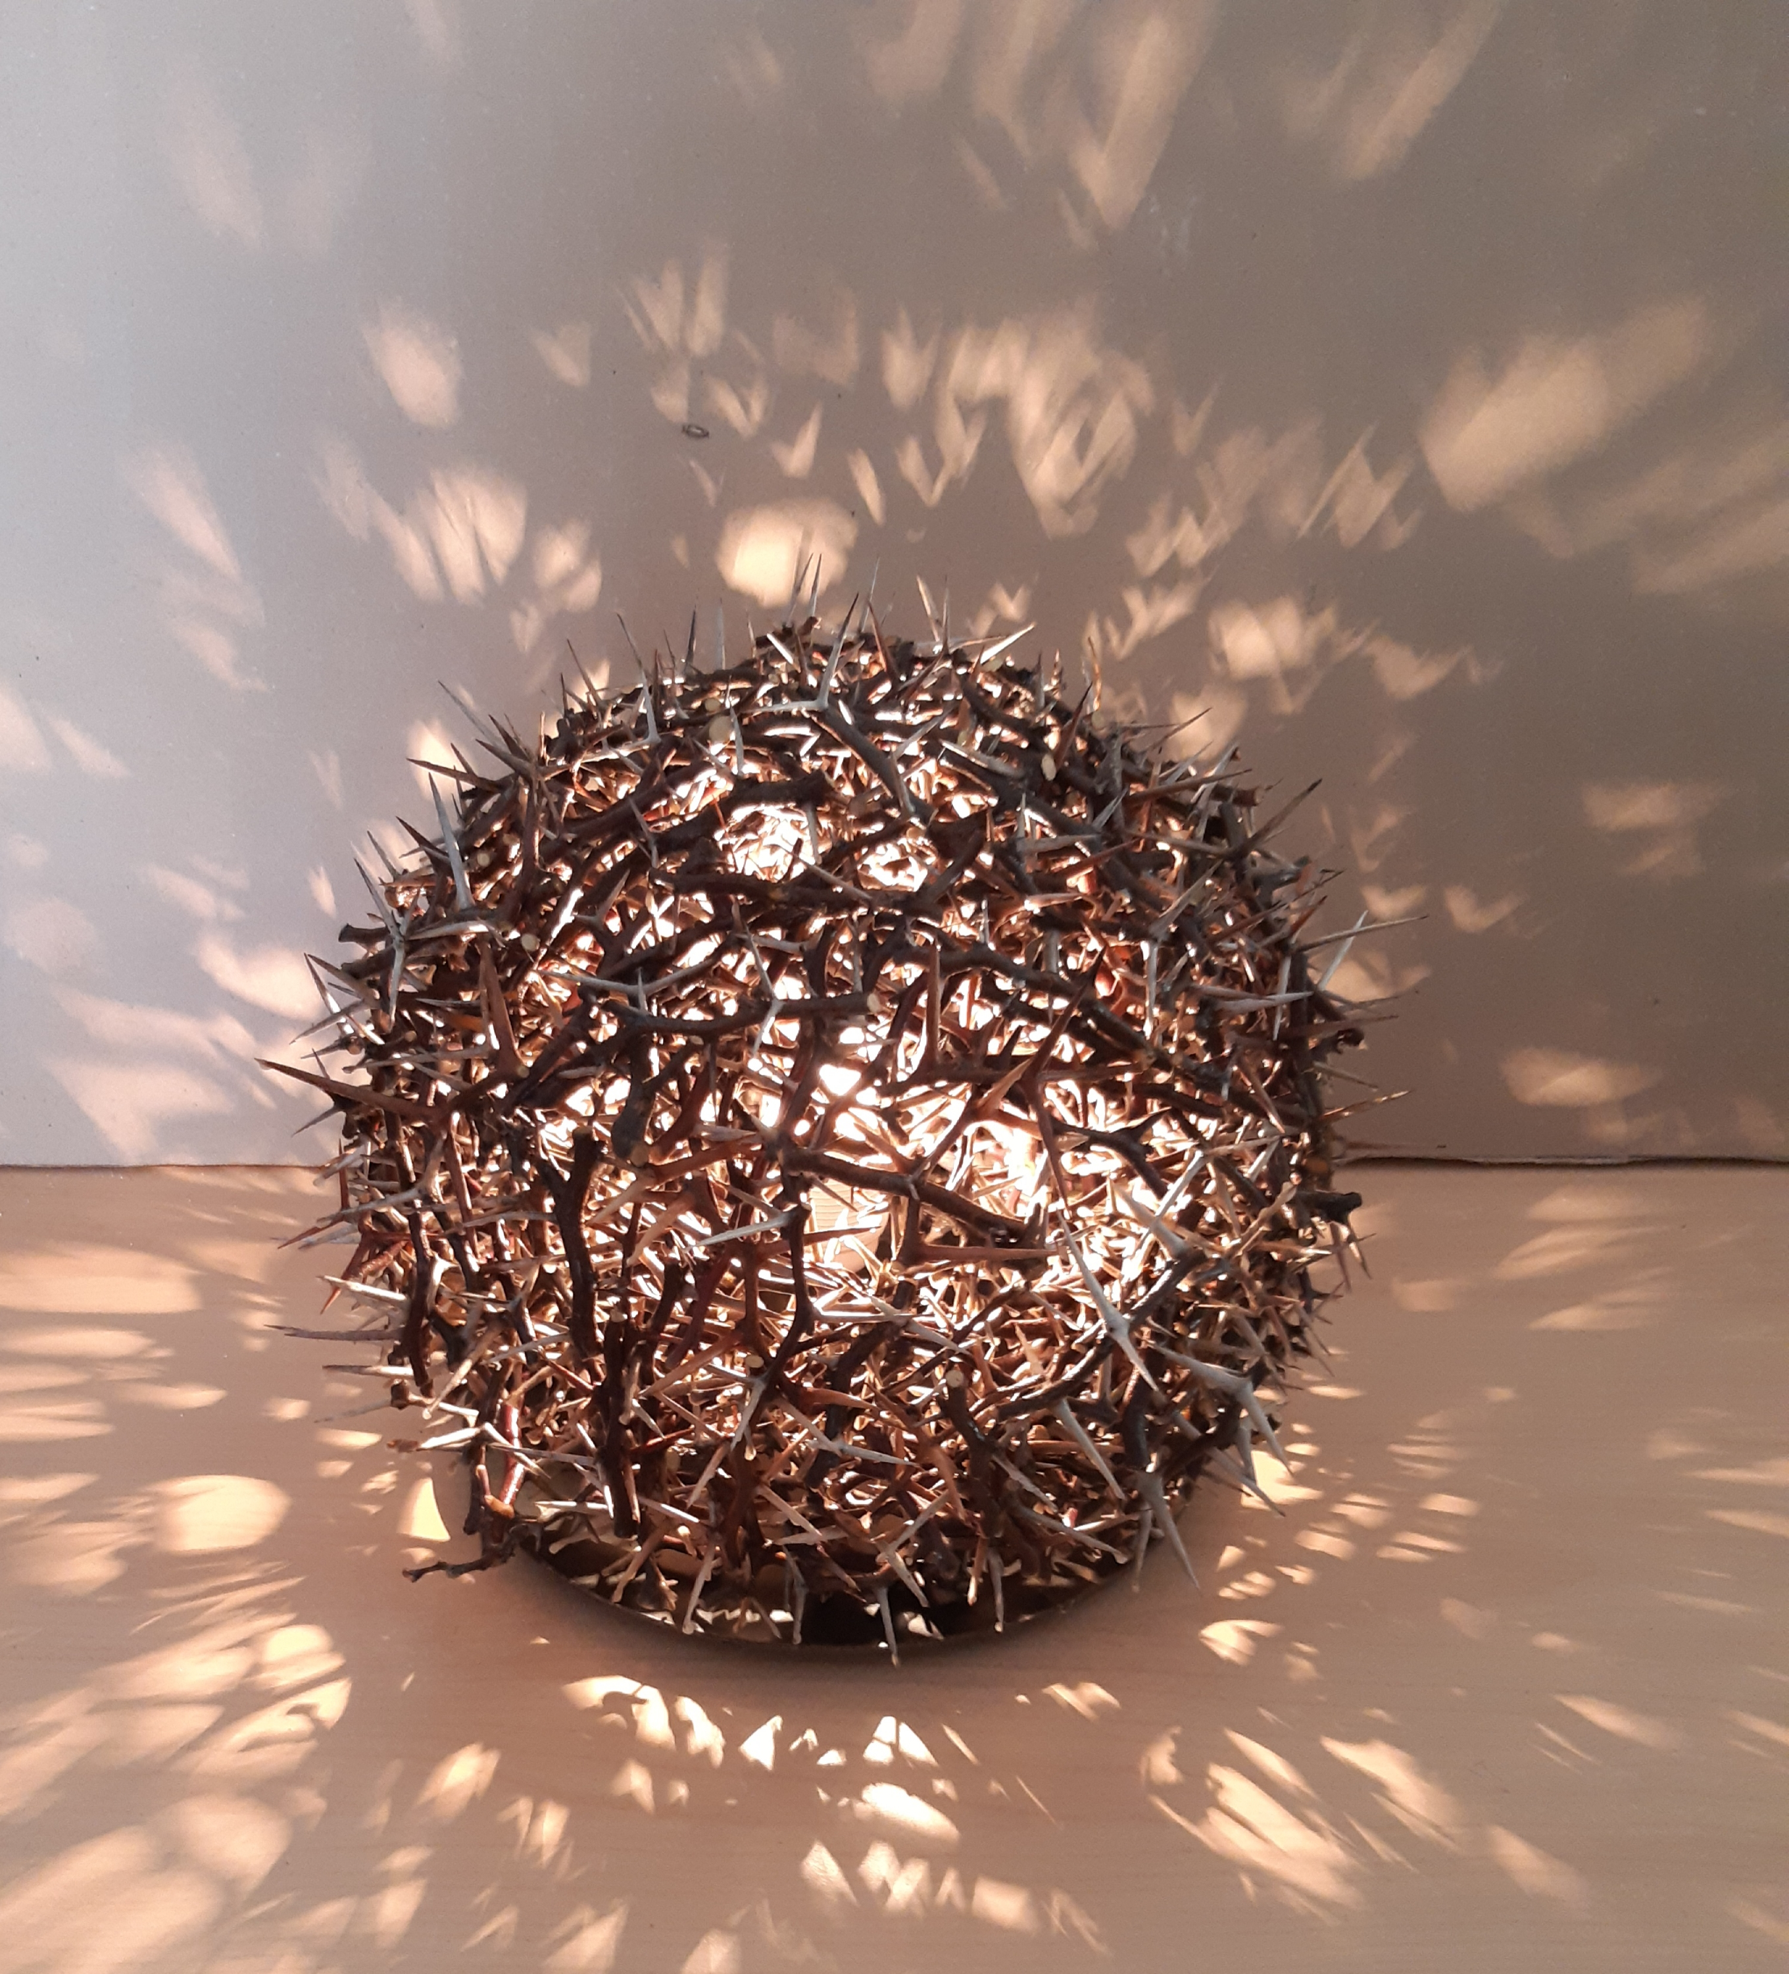 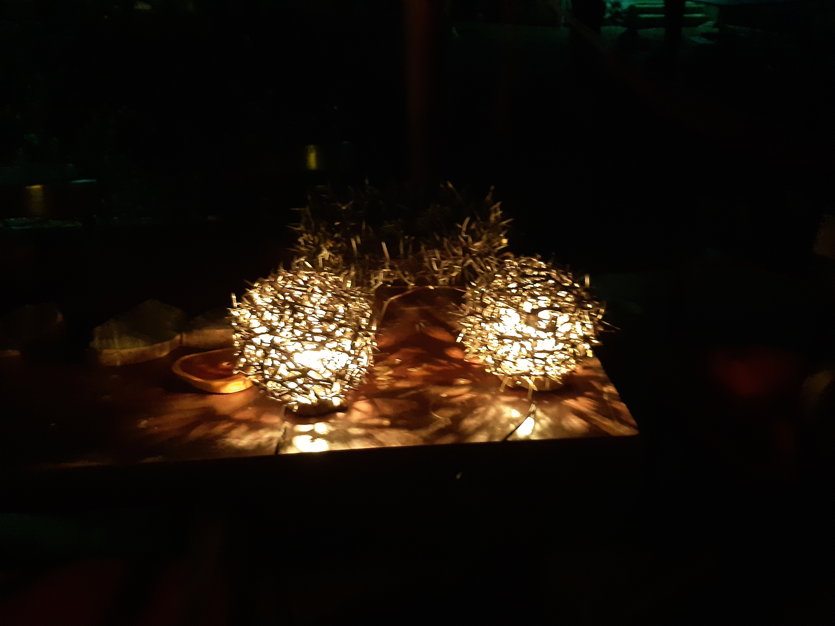 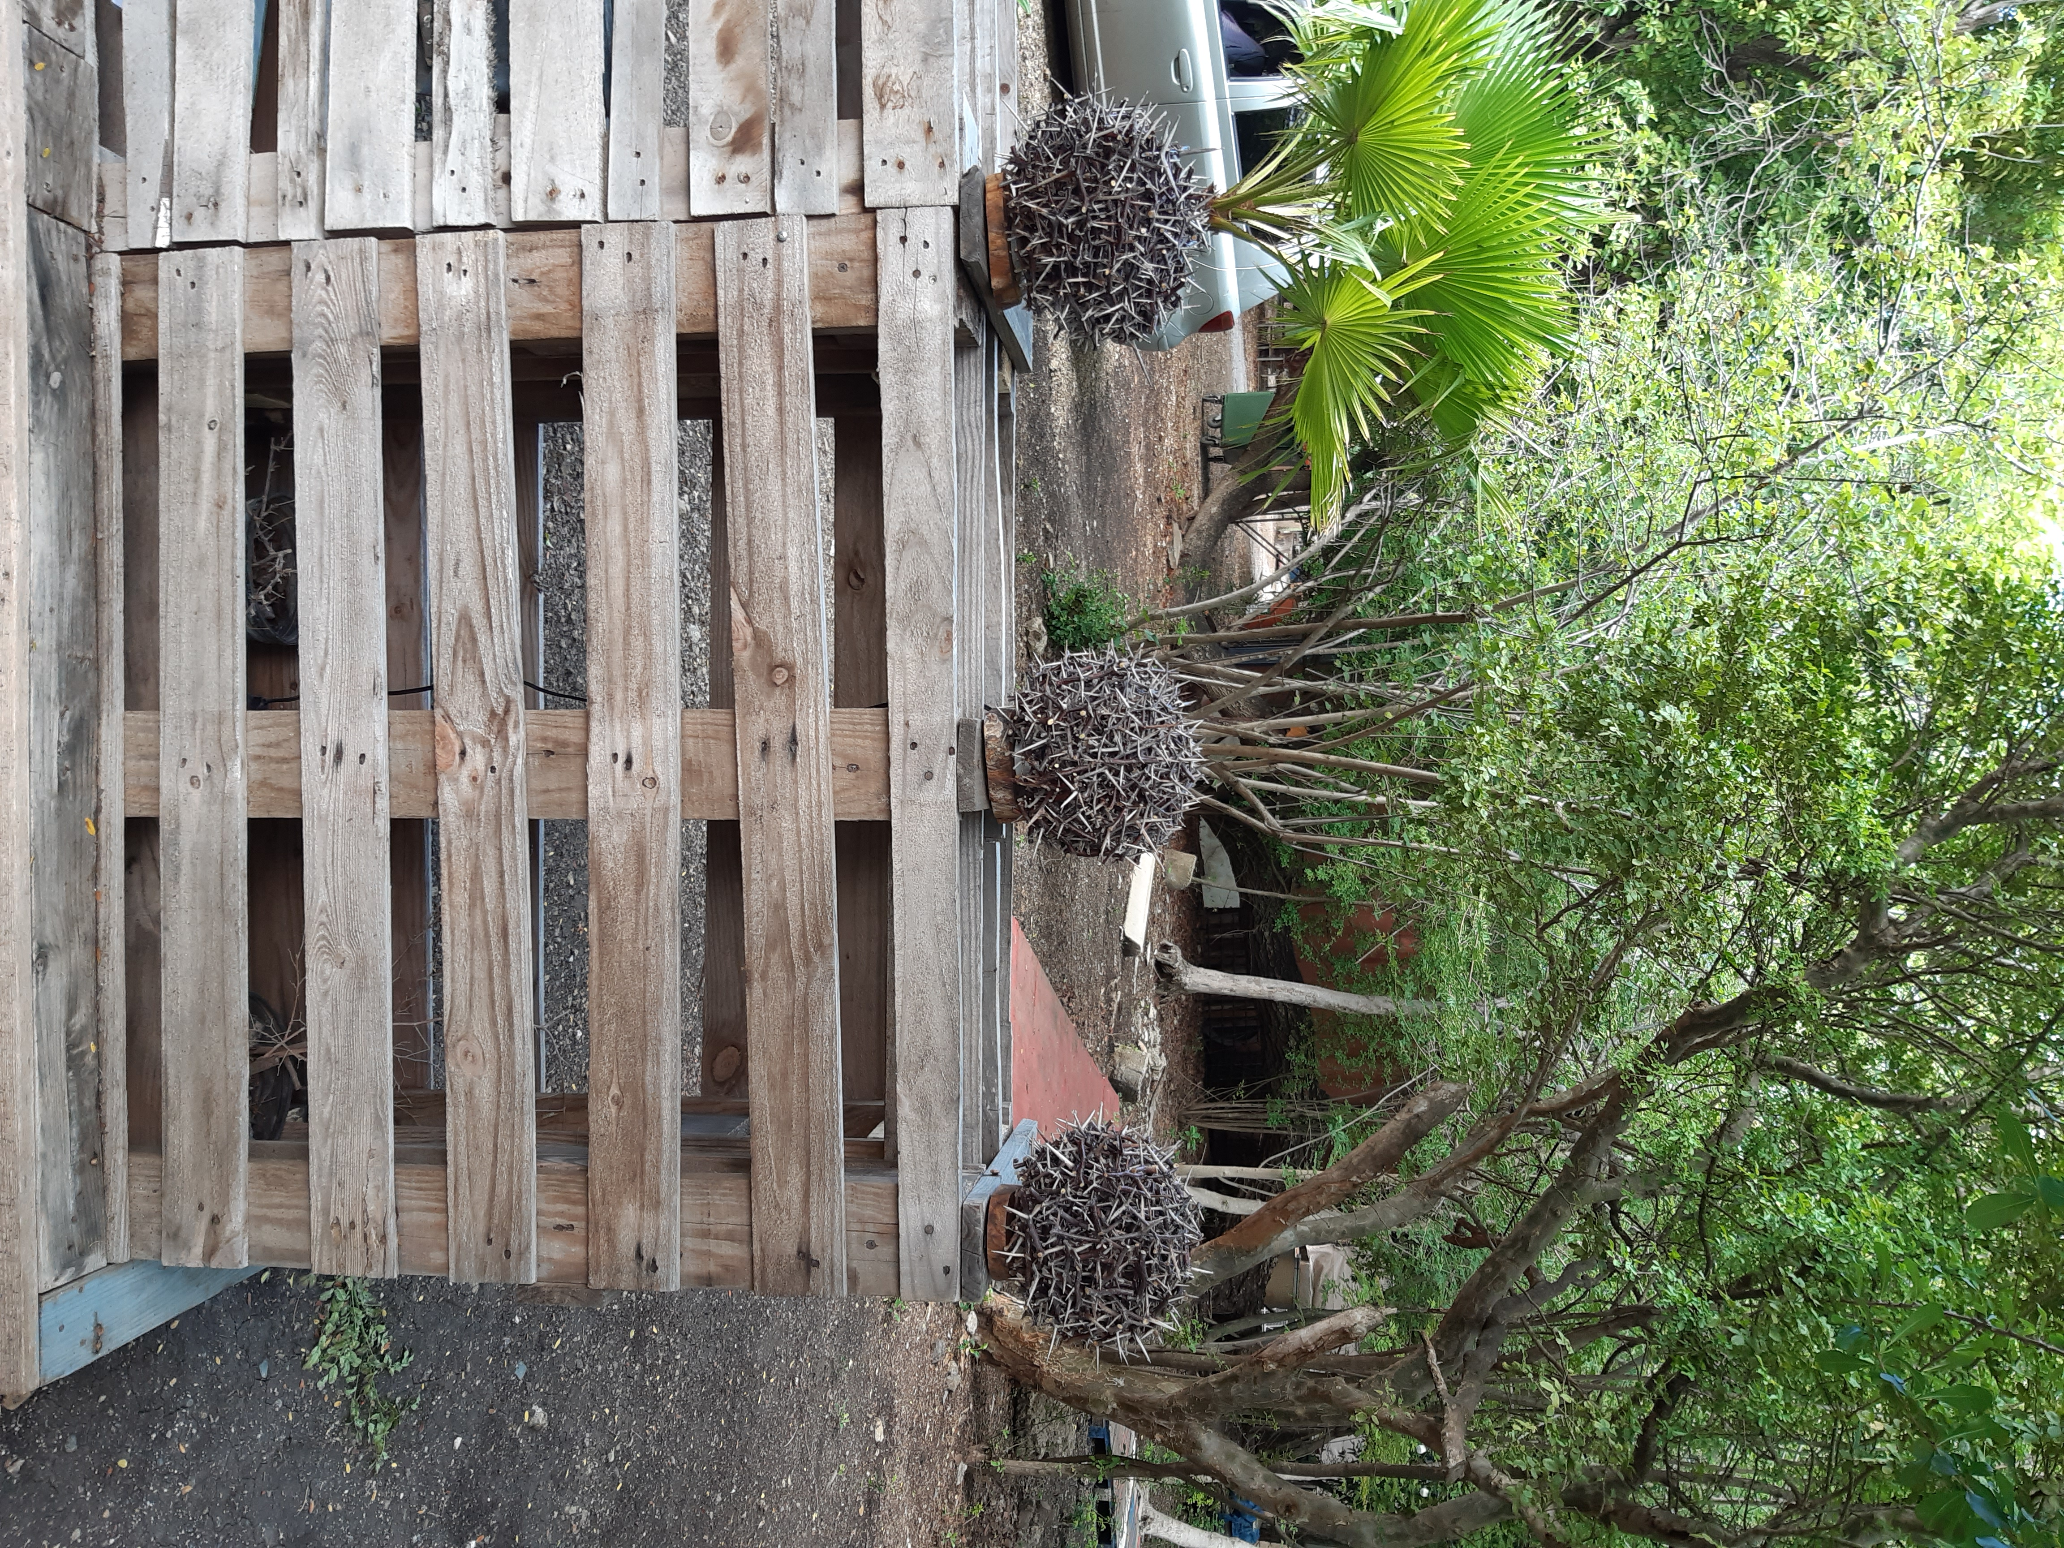
Thorns The Light Witin Ø 20 / 25 cm ANG 295 / Euro 140
Order now! It is handmade and needs time to dry :-) If you prefer a larger size, please feel free to contact us *Transport service is not included
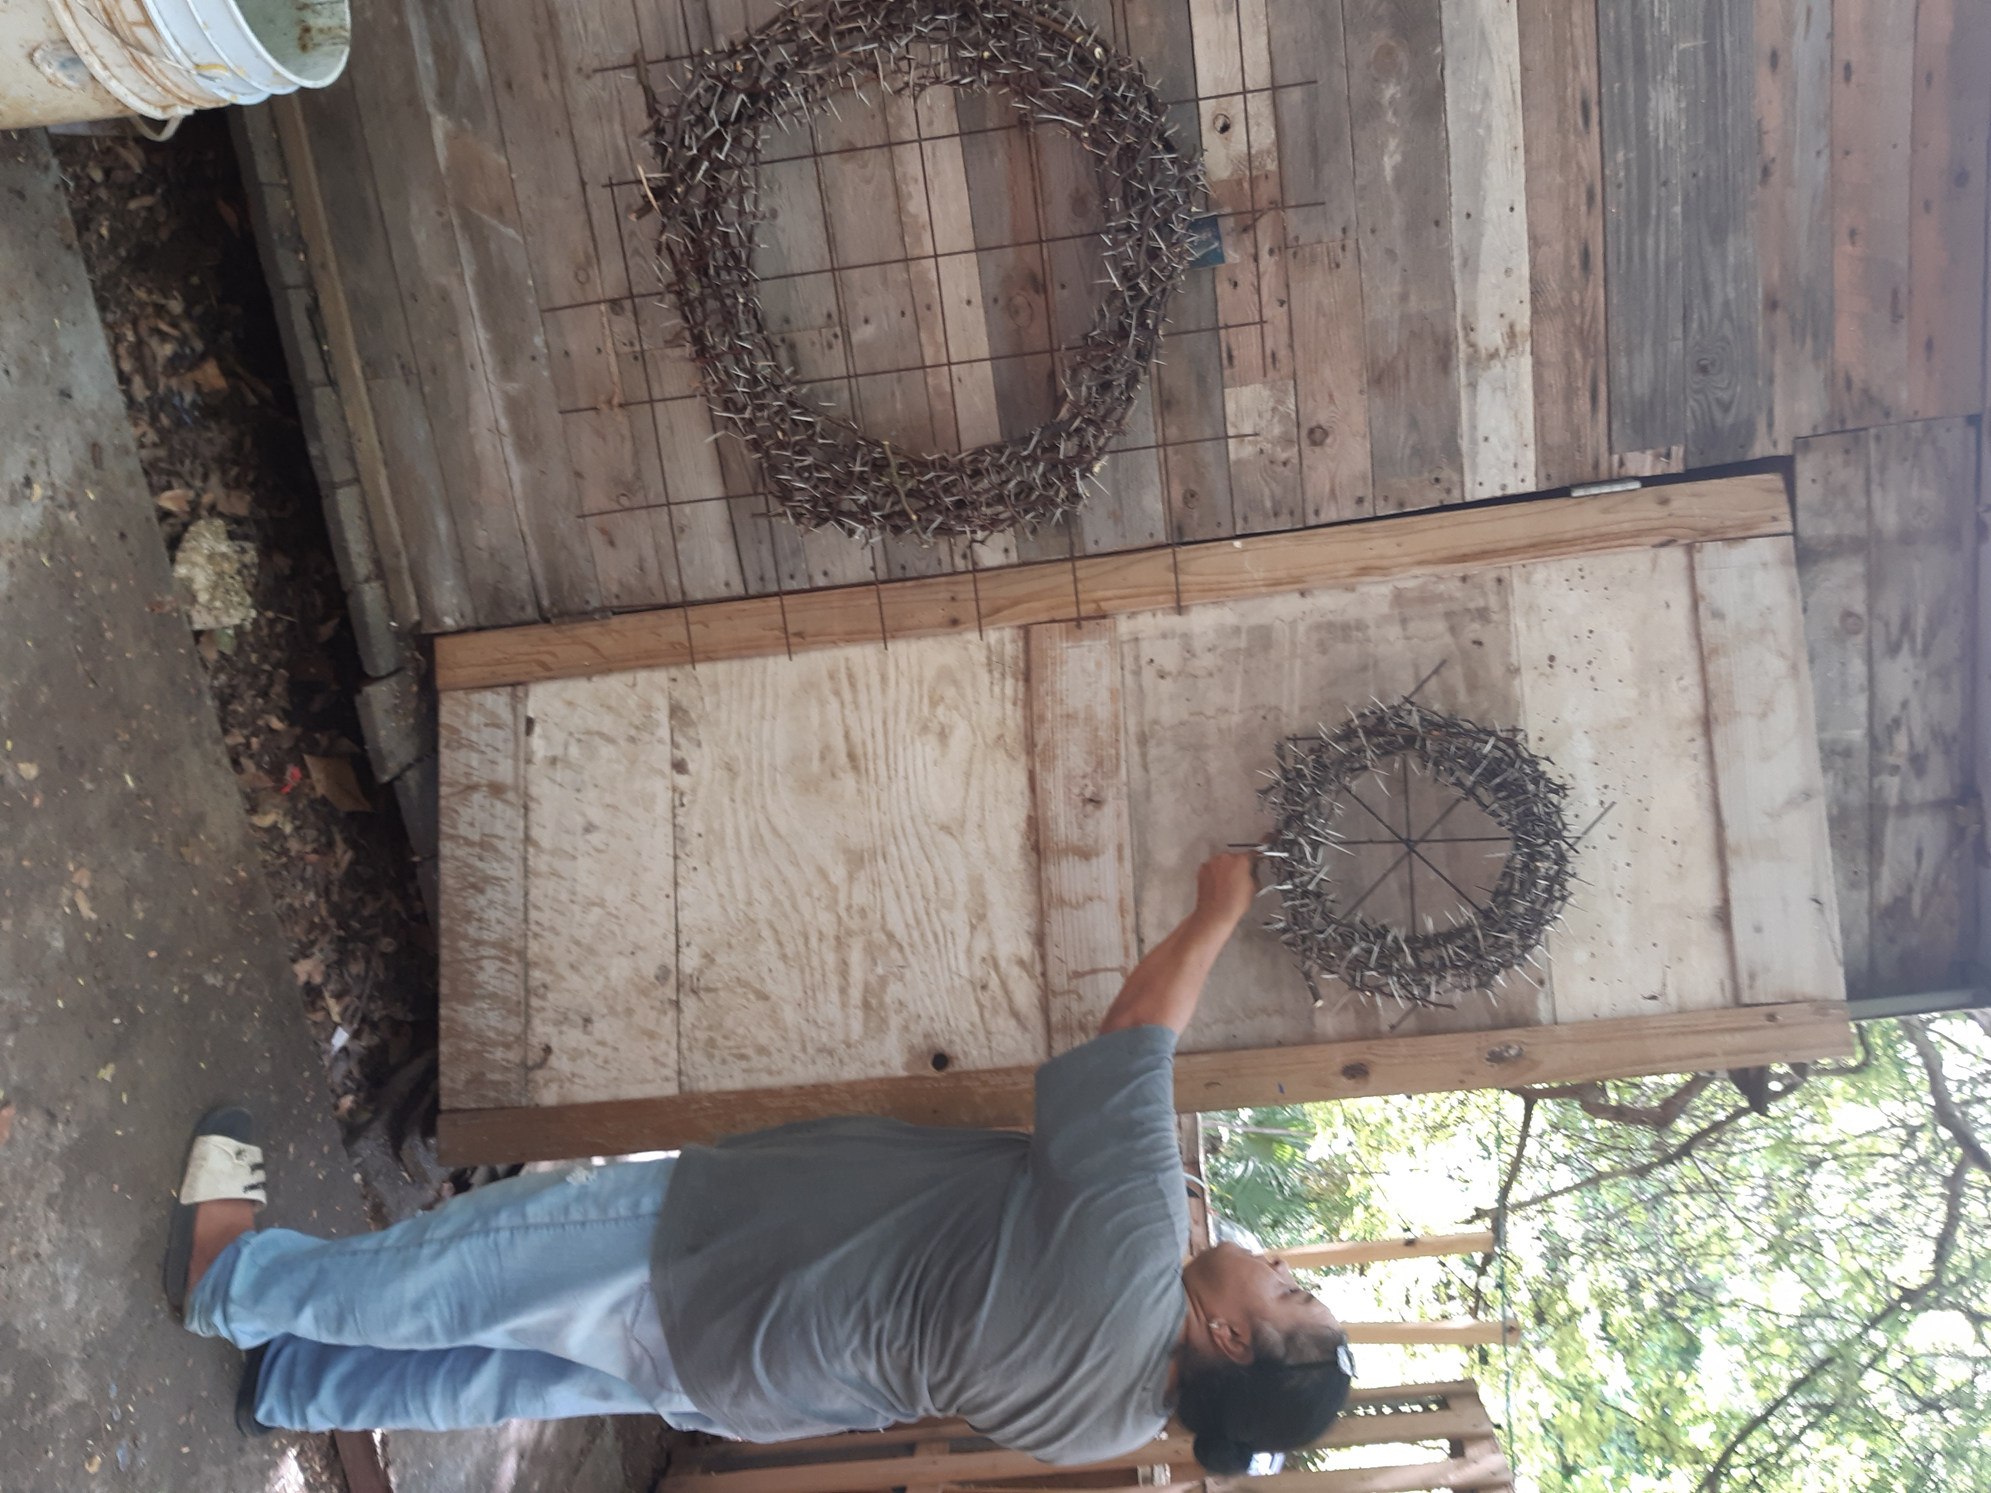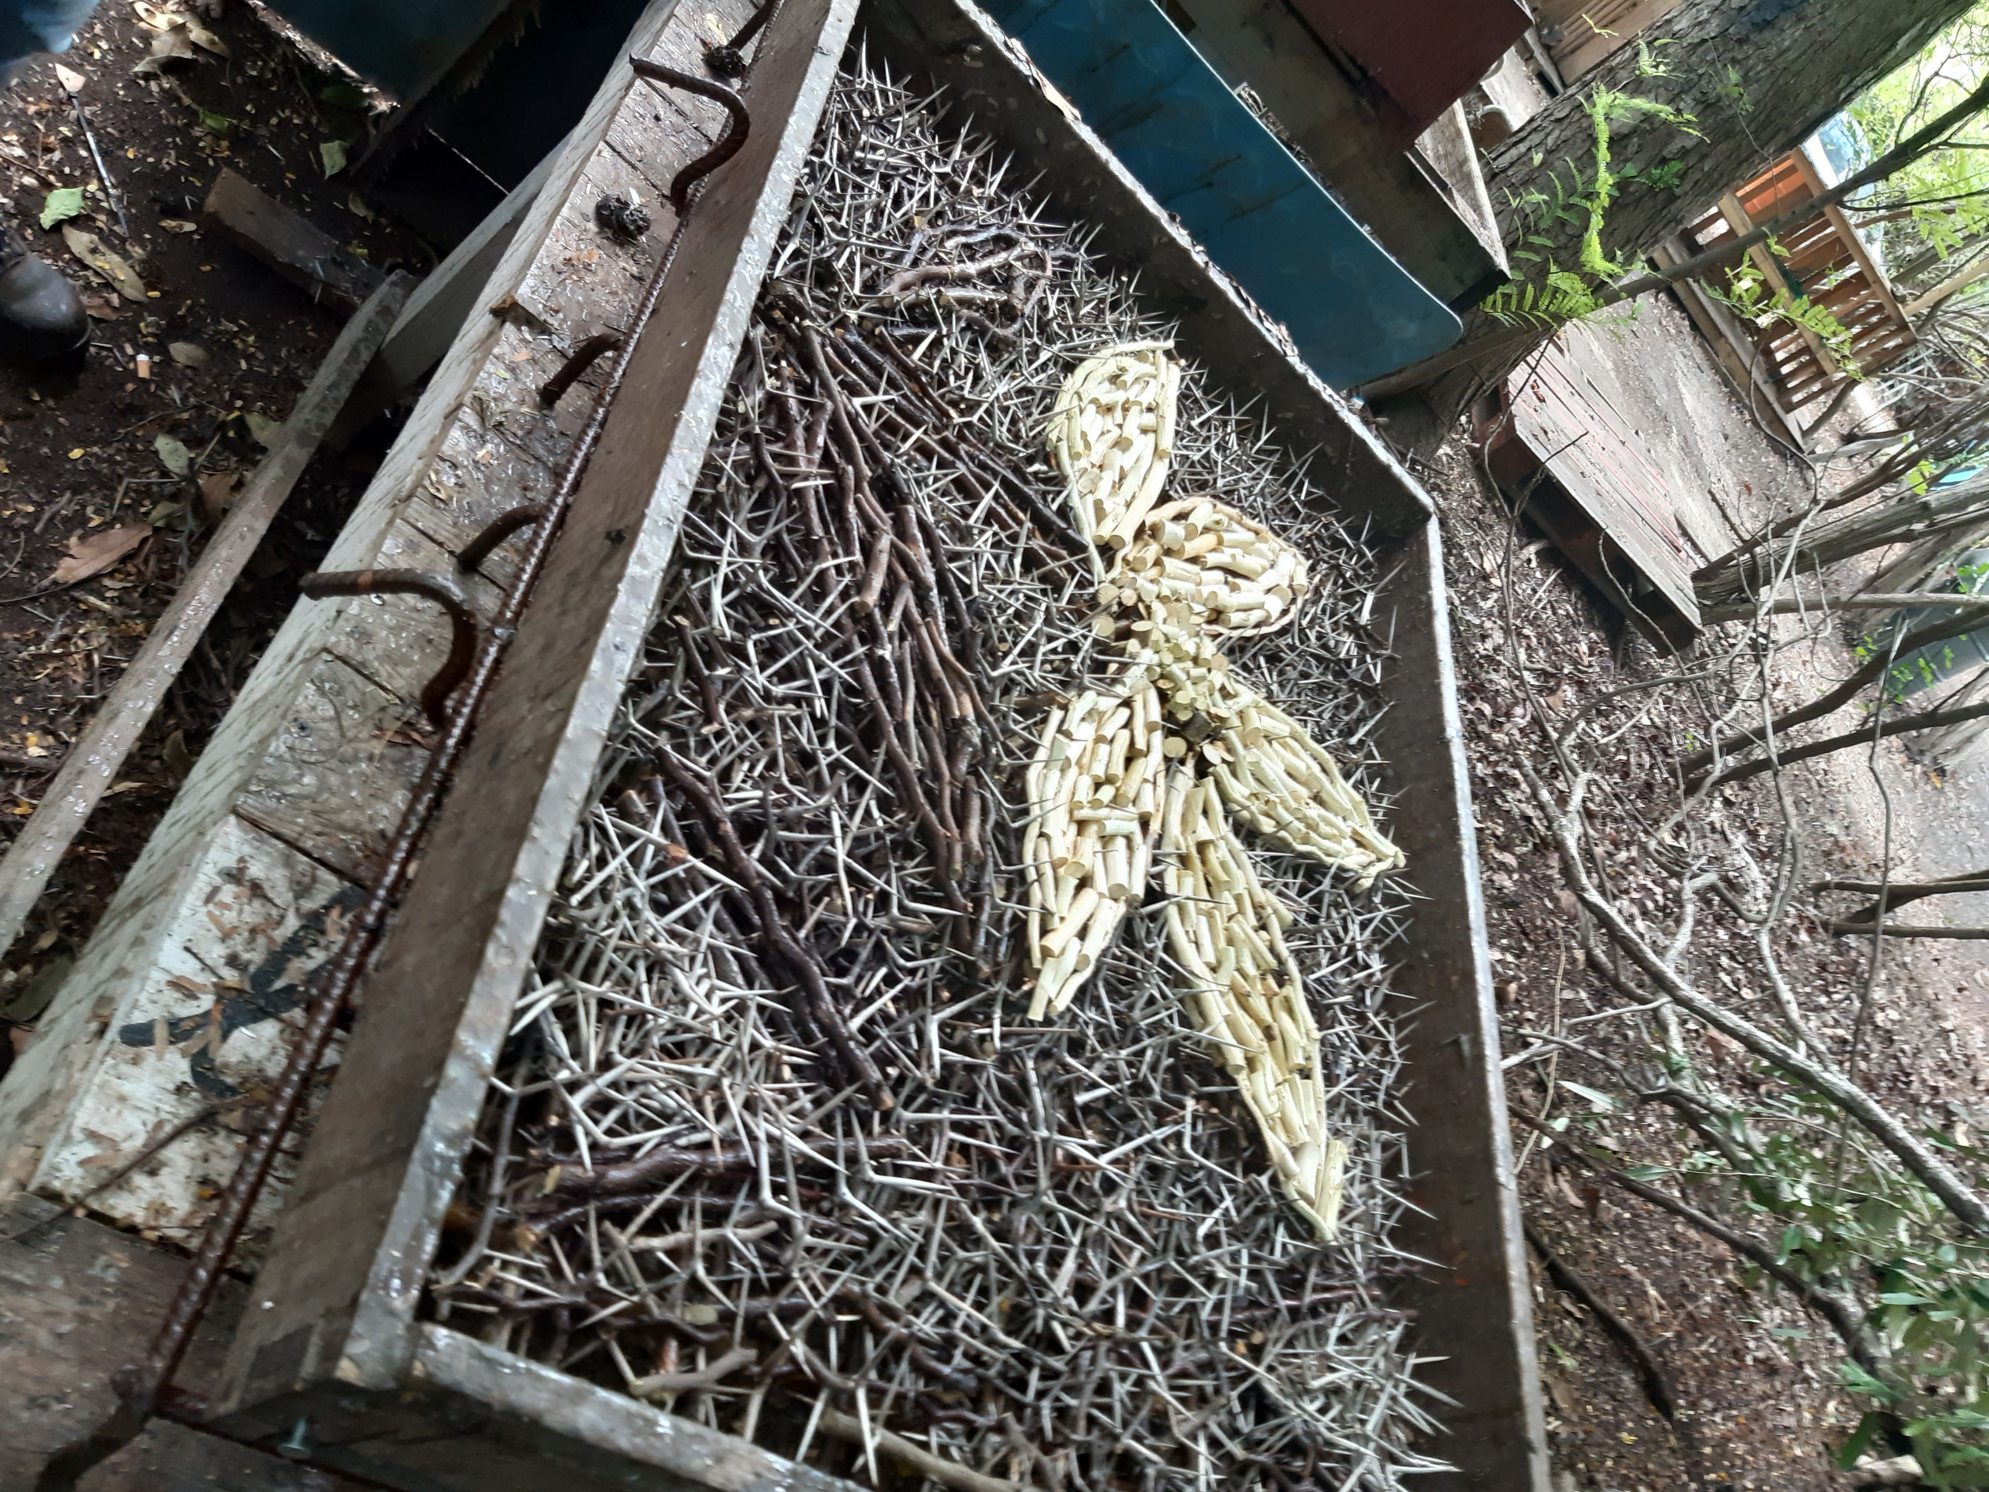
Wreaths by Gigi Sumpiña Flower Power
For the early bird Sumpiña wreaths
Ø 45 cm ANG 125.-/ Euro 62.50
The handmade lamps and wreaths are now in the making and stocks are
limited. Delivery time 3rd week of November and 3rd week of December for local use. Lamps can
also, be delivered in the Netherlands by air freight (10 days) and by
sea freight (1 month delivery time).
All shipping costs (packaging, shipping agent, CIF, etc.) are for the account of the buyer.
We will coordinate the shipment for a small service fee.

But be on time because the stock is limited 
And in November available tie-dyed angels on silk
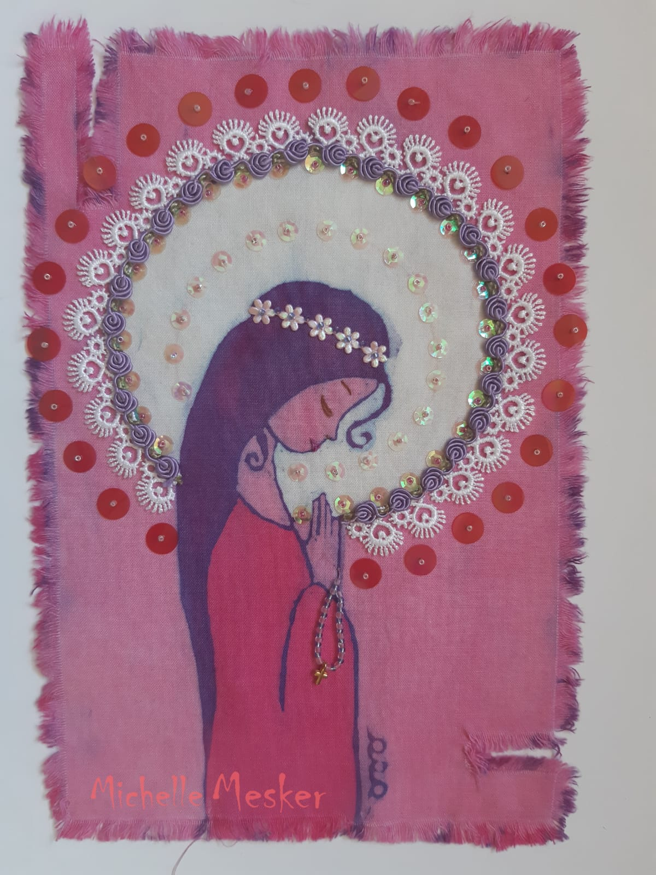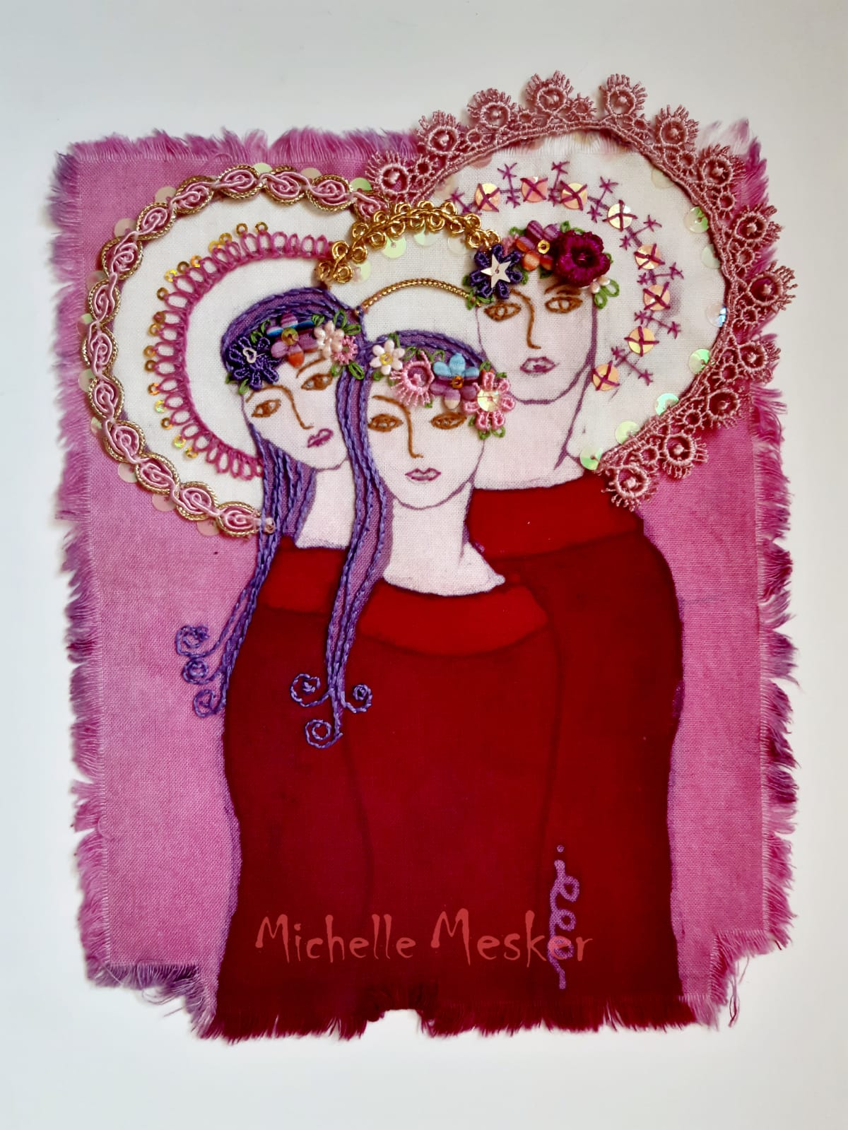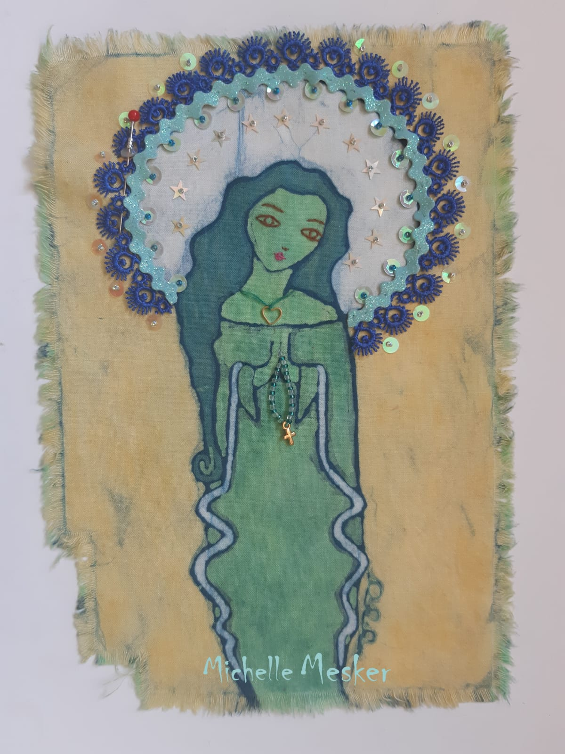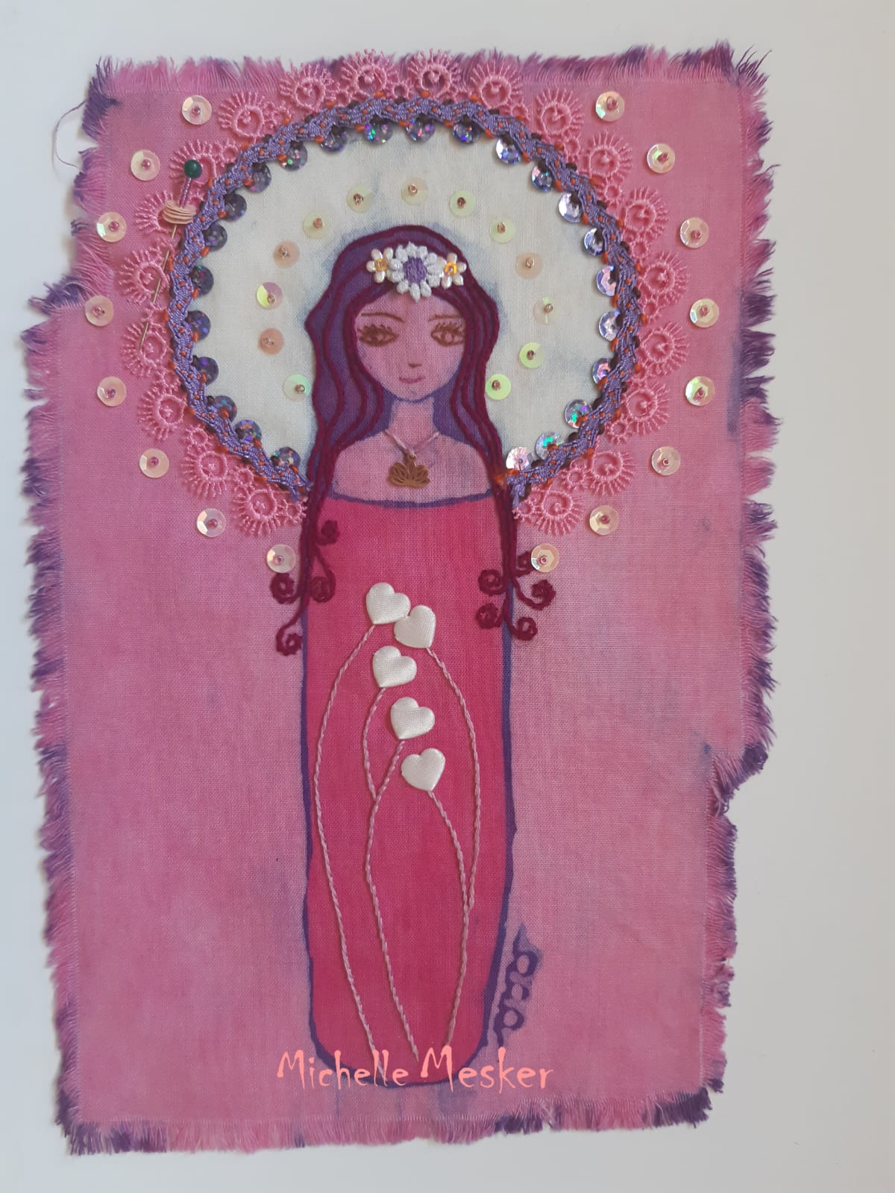
Michelle Mesker " Angels 2020"

misschien hier de actie aankondigen ....
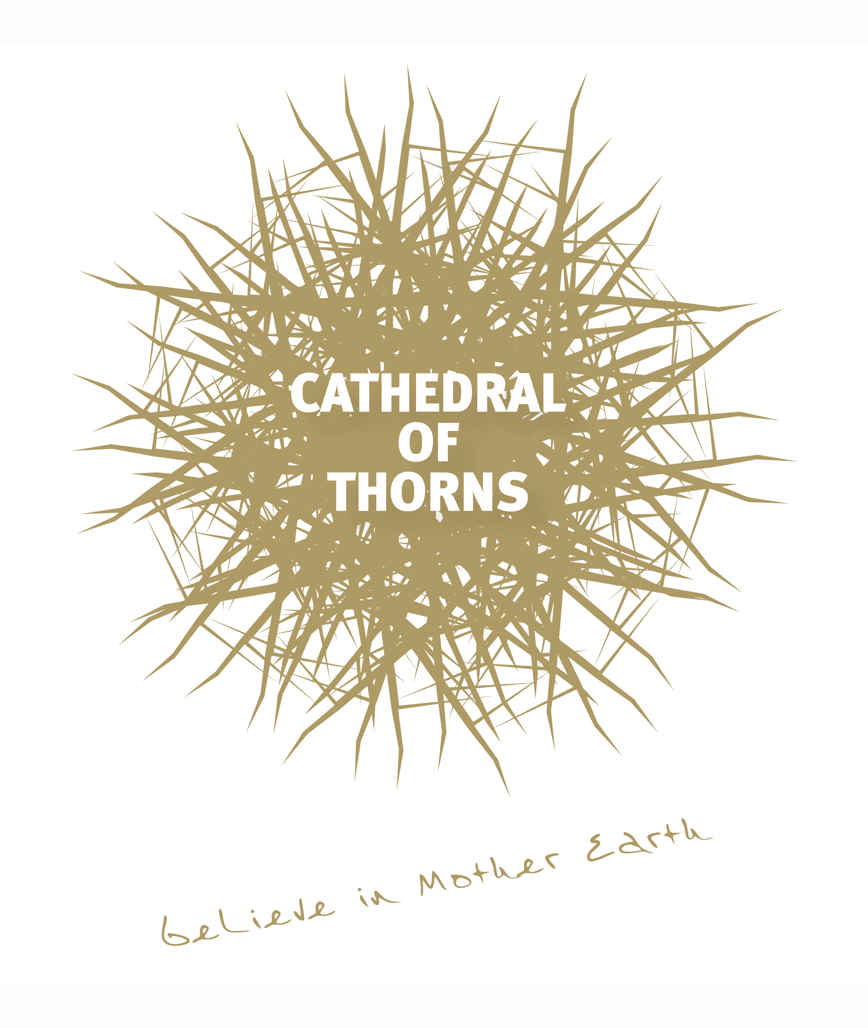 Want to support the Cathedral of Thorns?
Your gift makes an impact on every aspect of The Labyrinth of Thorns.

WORKSHOP Paint your batik bléki
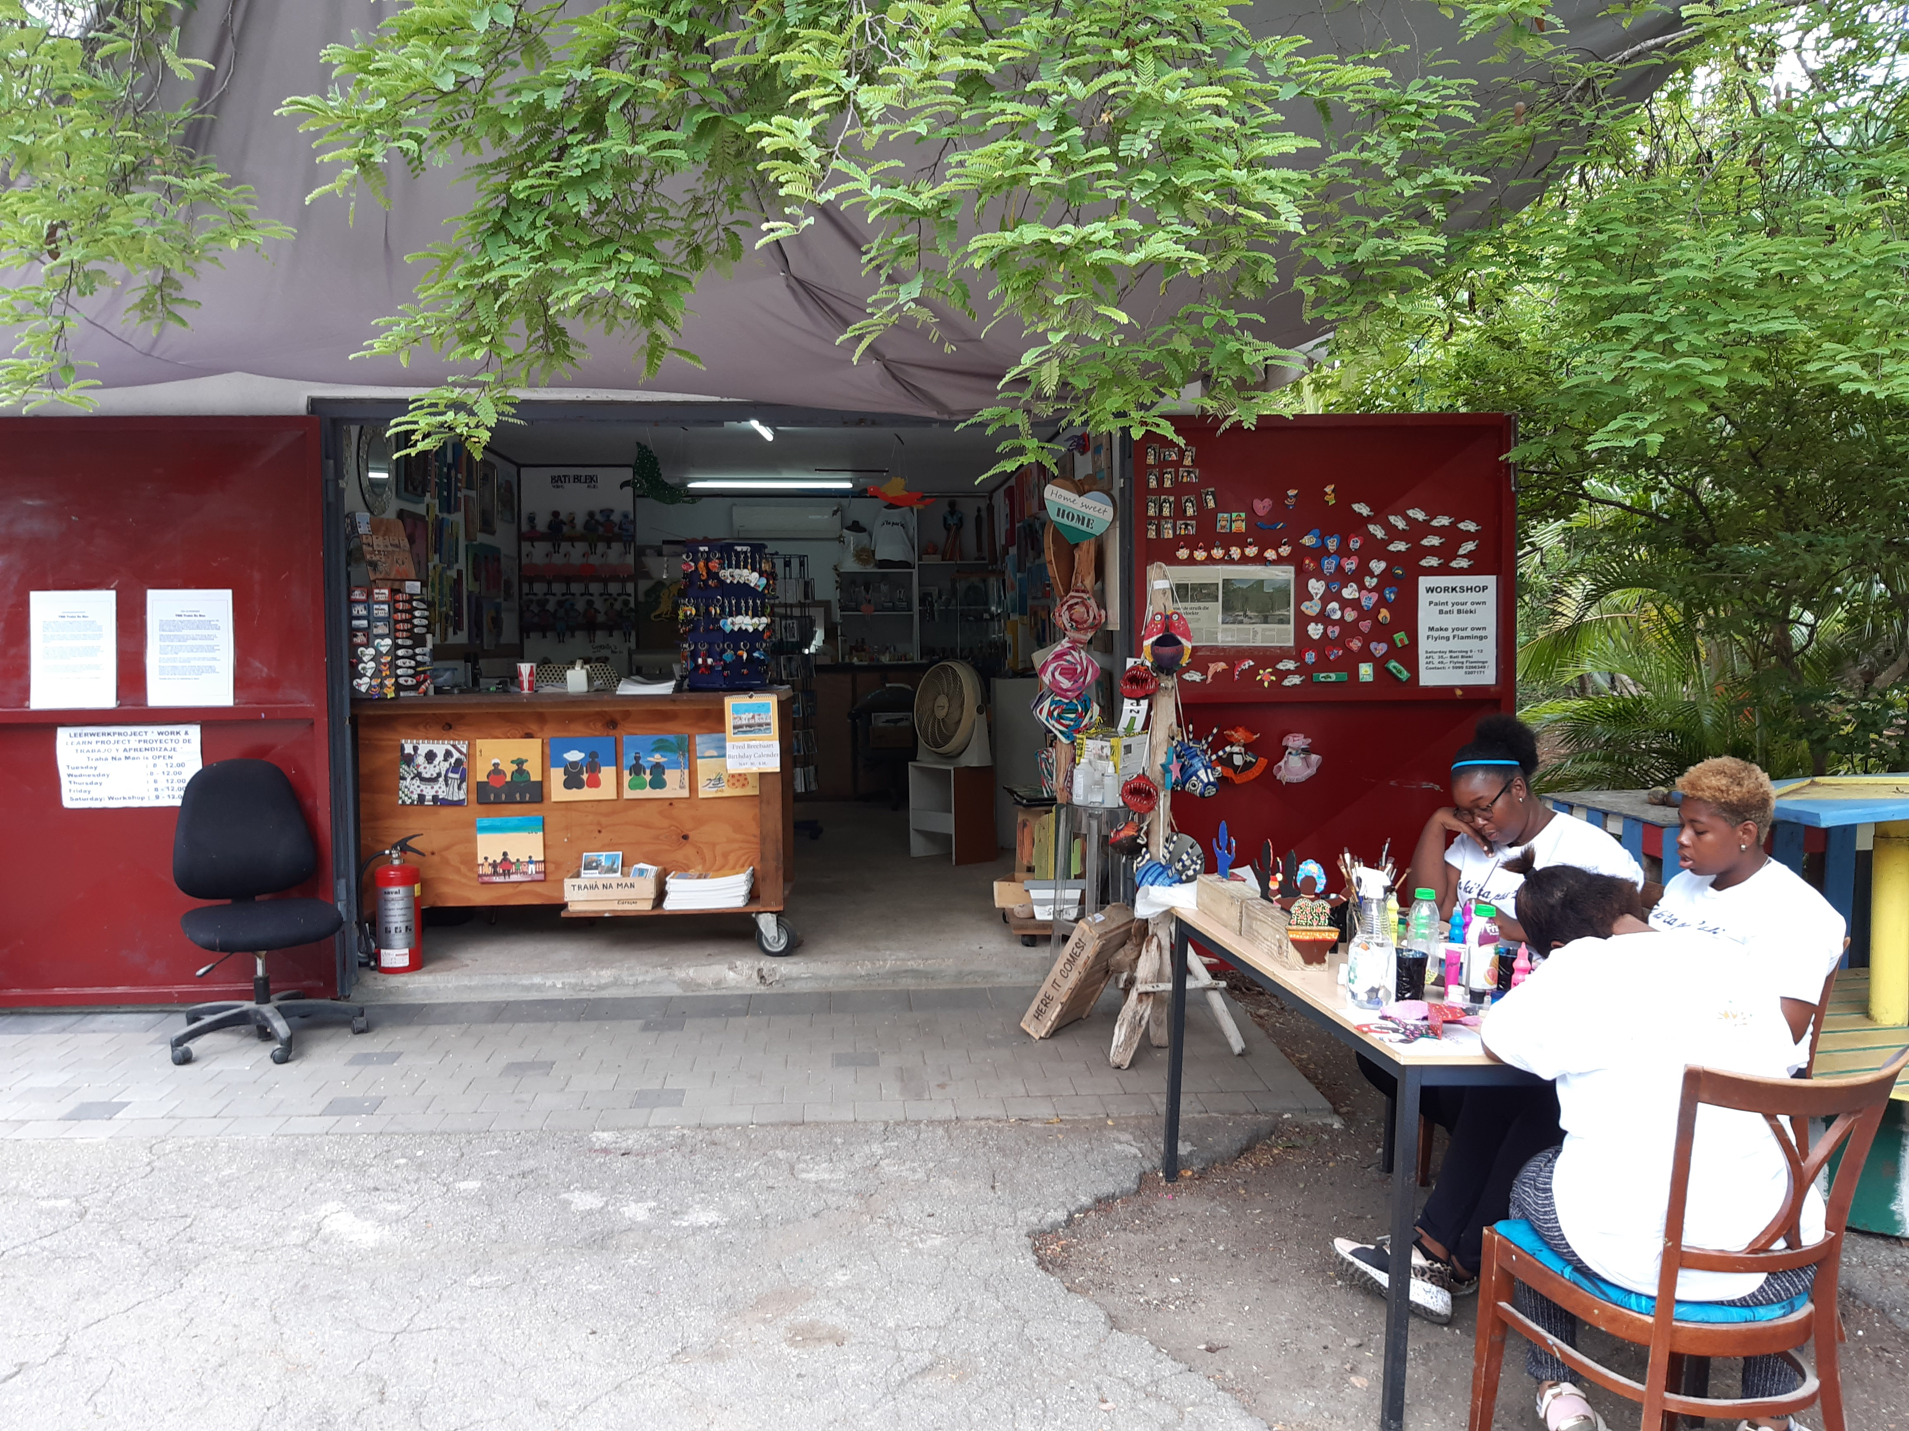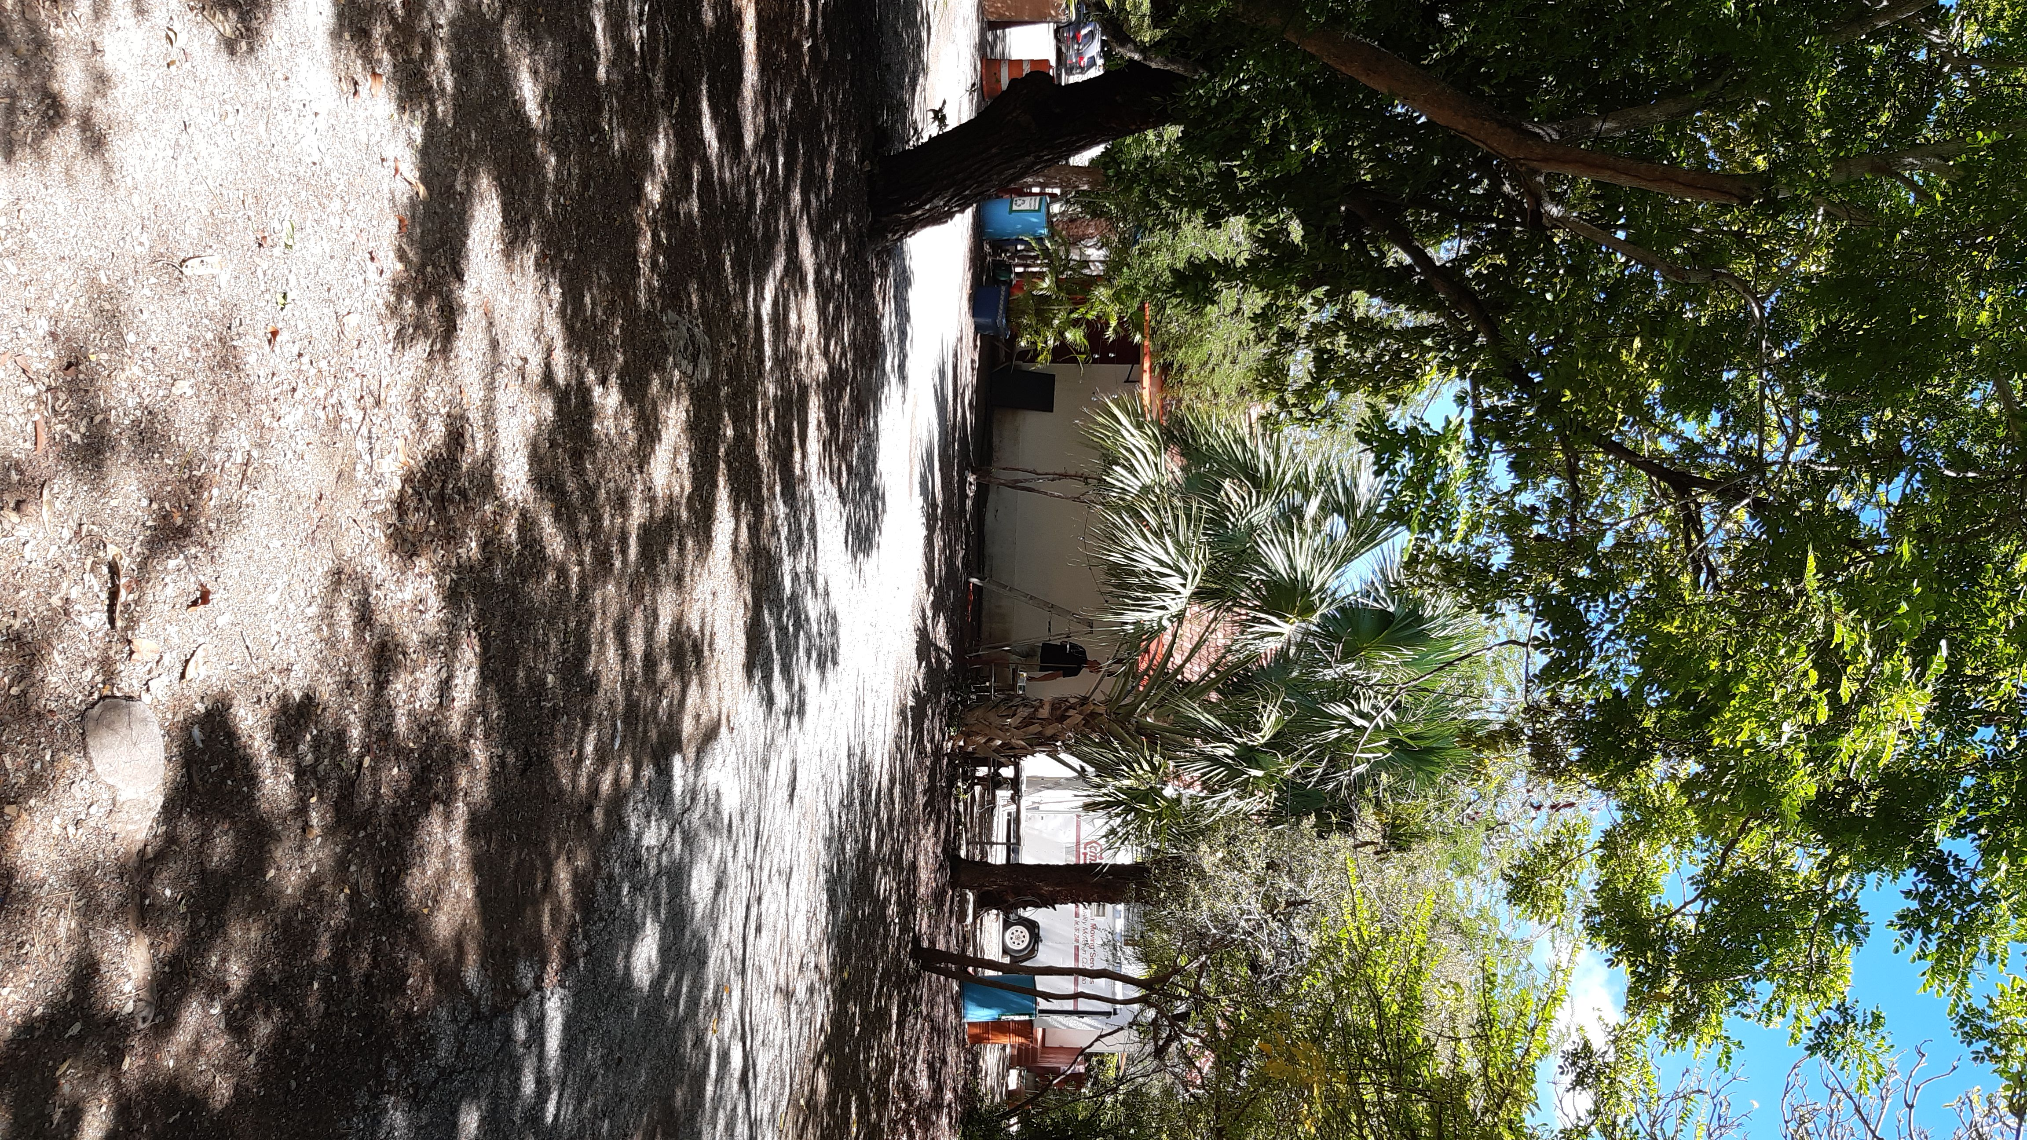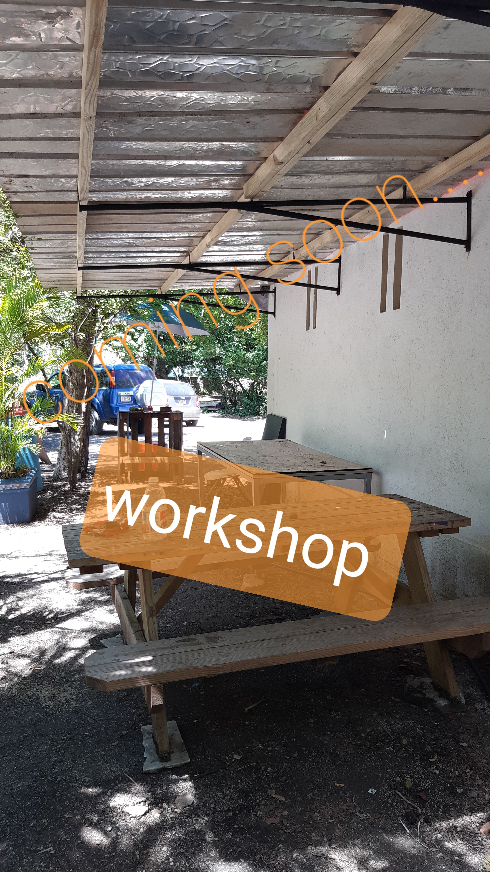
Handcraft By Mon Art New workshop space under the Tamarind tree :-)
Saturday, 17 October
Acrylic Painting Bati Bléki / From age 12
Coached by: Esther Caprino
From: 9 am - 12 am
Ang. 39,00
Limited seating: Make your reservation now
Since the situation around Covid-19 is constantly changing we strictly adhere to the social distancing and hygiene guidelines to guard your and our personnel's health.
Visit our Store
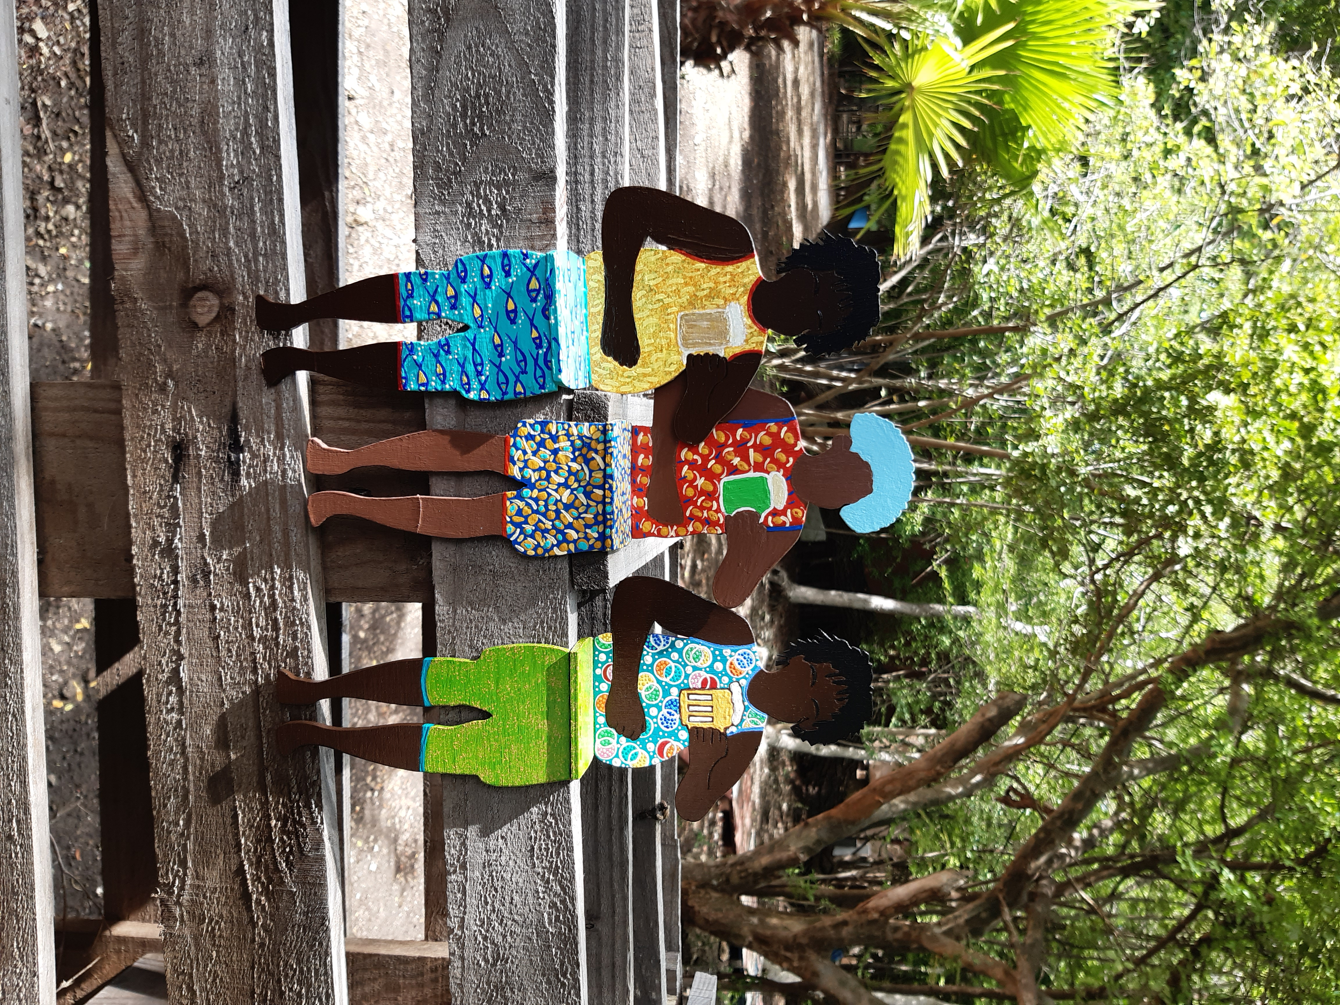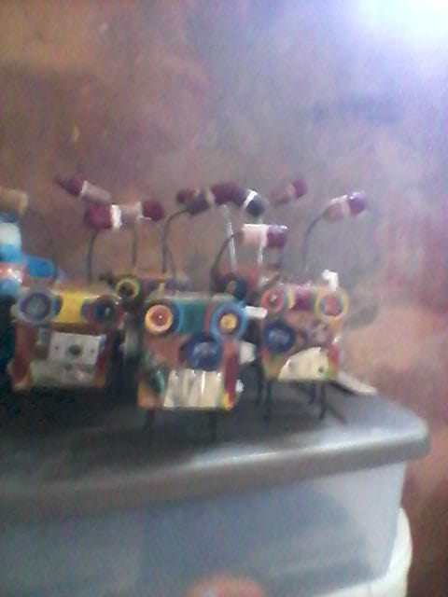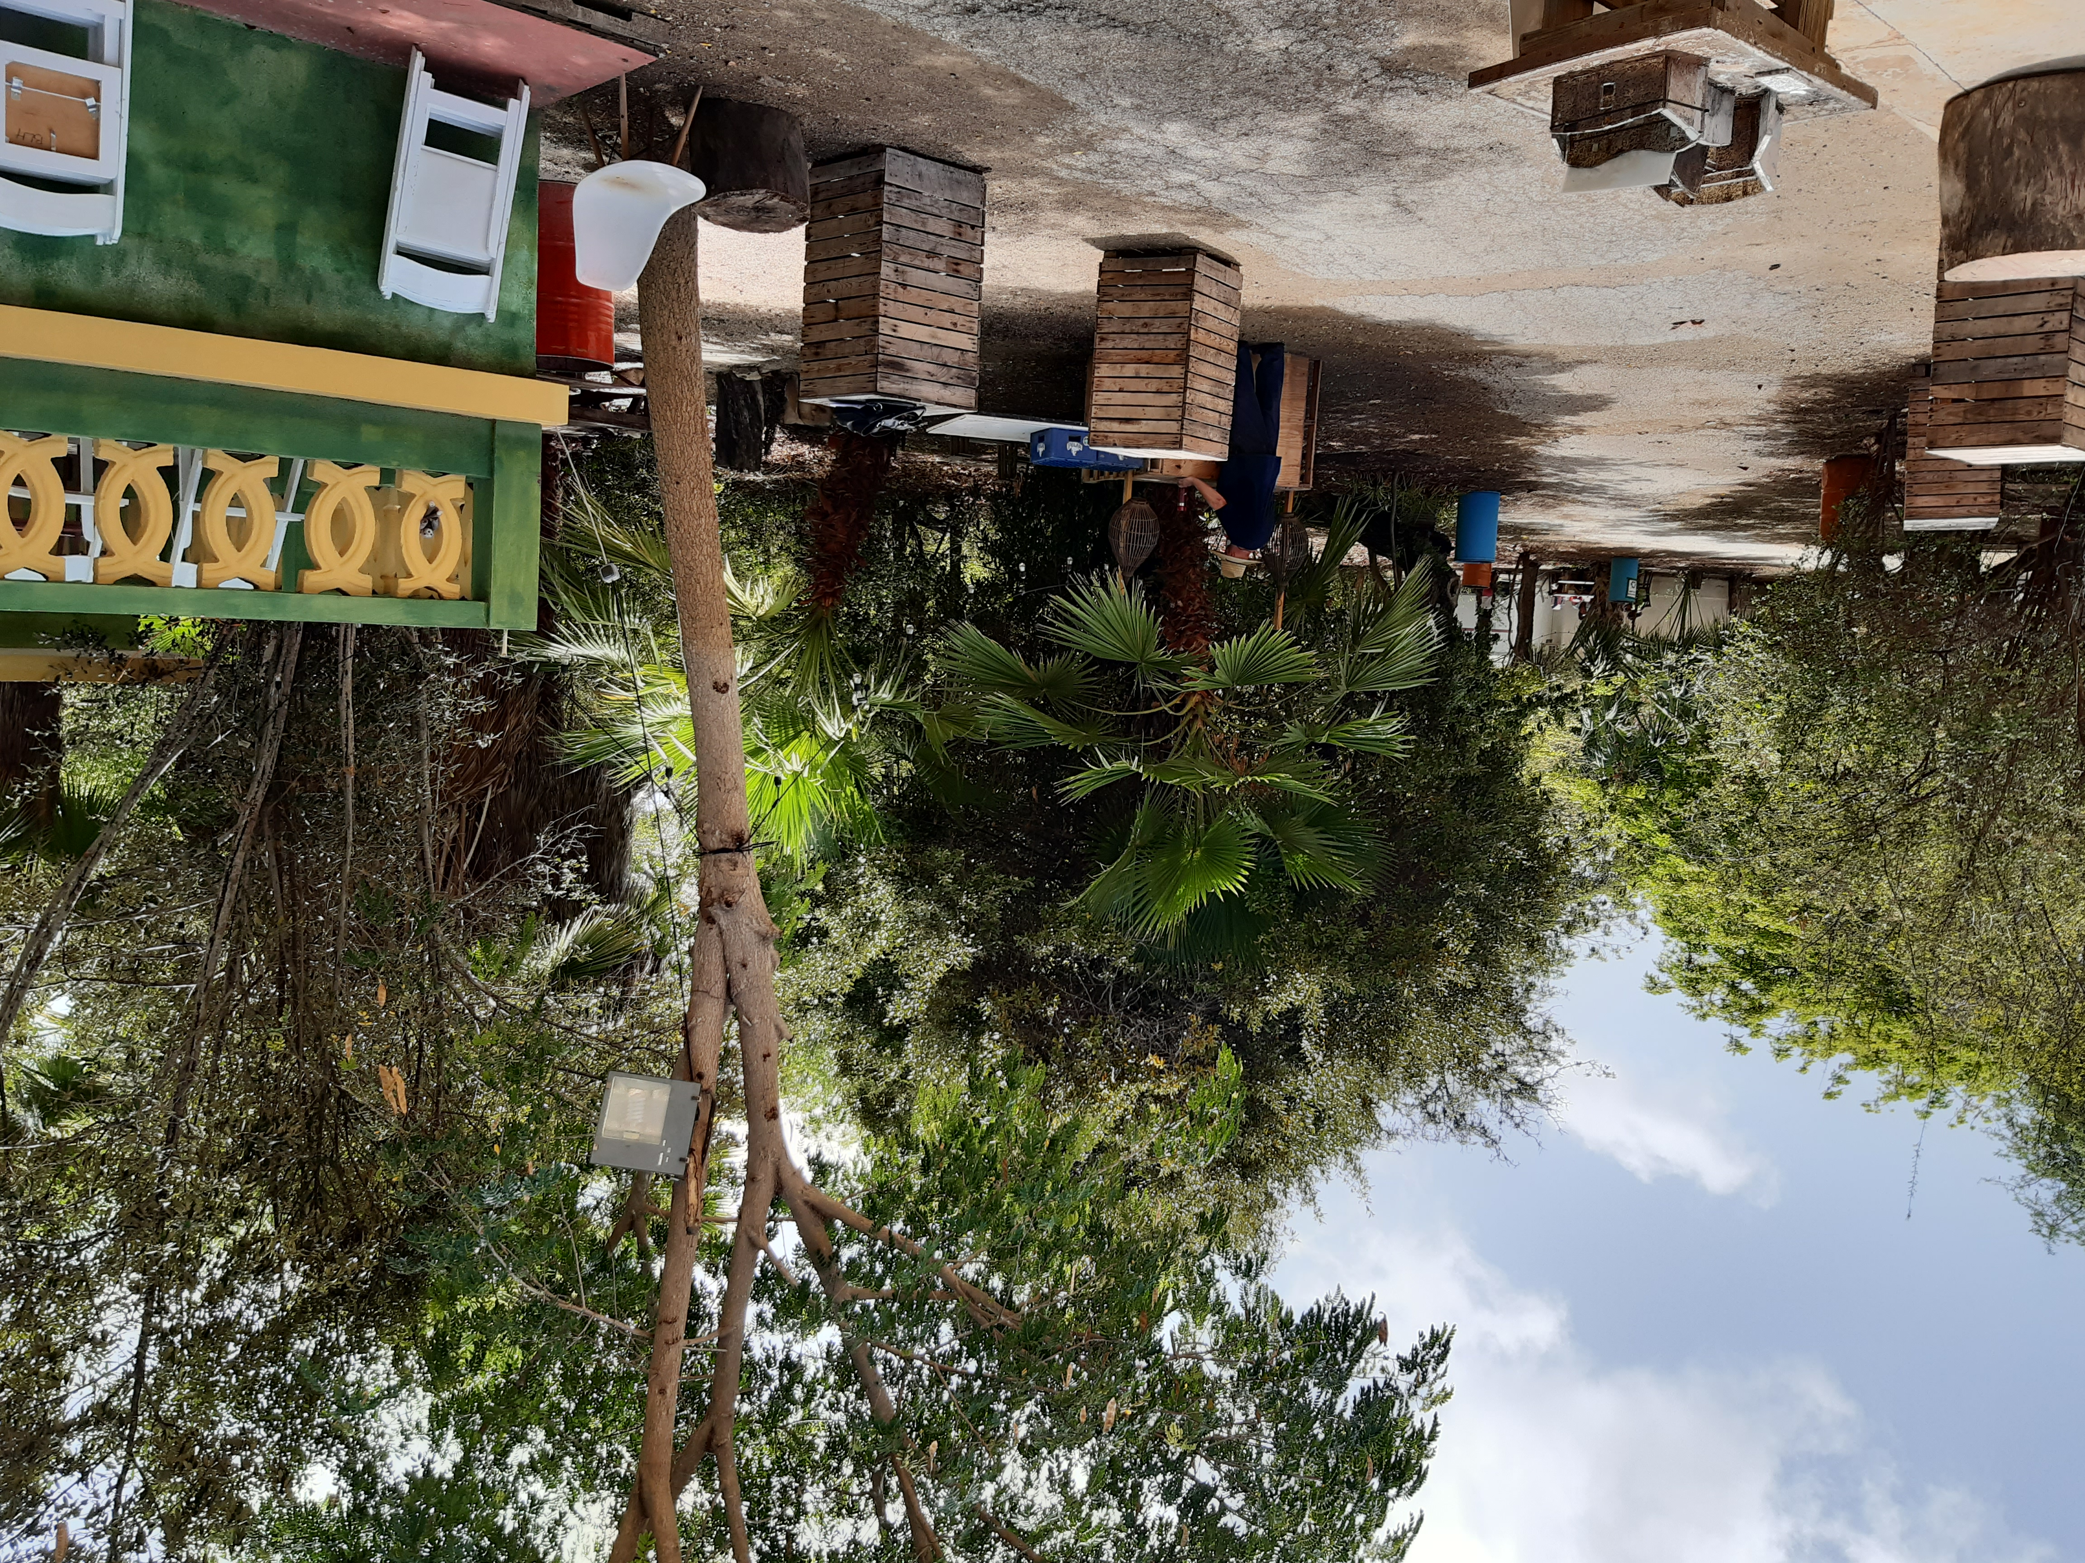
Chatting Boys Chalimar's Robots Visit the Cathedral of Thorns

Handmade By Mon Art // Santa Rosaweg # 8 Next to Restaurant Number Ten // Facebook: www.facebook.com/......Insta // + 5999 526 63 49

